MAORI HEALTH STRATEGY

Executive summary
The above study has provided an insight of health outcomes and opportunities of an Ethnic community of New Zealand namely Maori. Poor health status may appear as a result of several complex factors in this Maori population. These inequalities are considered as pervasive and large over time and across lifespan. This Maori health strategy can be linked with several threads. Whänau community of New Zealand is mostly evident of certain health factors
Whenu represents all of the different individuals who work collaboratively to create Maori health. Health strategies formulated by government of New Zealand is helpful in providing wellbeing towards Maori collectively as well as individually. Clinical training agencies and mental health funding has also supported to bring improvement in health of Maori people.

Table of Contents
Introduction 3
Rationale aim and target group of strategy 3
Methods of aligning of Maori health strategy with New Zealand health strategy 2016 6
Health initiative that has been implemented in order to aid achievement of strategy 8
Way to improvement of health outcomes by initiative supports 9
Conclusion 10
Reference list 11

Introduction
He Korowai Oranga refers to the term “Cloak of wellness”. This portrays a cloak that nurtures, develops and embraces people spiritually and physically as well. A typical term raranga refers to weaving of Korowai people. In this weaving strands are termed as aho or whenu. This Maori health strategy can be linked with these threads. This whenu represents all of the different individuals who work as a team to create Maori health. Their primary focus is to attain maximum wellbeing and health. In this study, the researcher will link Maori health strategies with New Zealand health strategy, 2019.

Rationale aim and target group of strategy
Poor health status may appear as a result of several complex factors. Whänau community of New Zealand is mostly evident of certain health factors. Significant disparities can be found in health status of whänau. In fact, it has been found in a study that amongst all group of New Zealand communities, Maori people possess an average of poorest health status (Breton et al. 2017). In order to eliminate or reduce such health inequalities regarding Maori people, central government of New Zealand has taken an initiative. This service priority, actions, objectives, goals and principles of this Maori health strategy has emphasised on improving Maori Health and well being. These include two significant Maori goals. These are appropriate and proper services for Maori along with creating opportunities for Maori people so that they can take part in all levels of health sector. Principal health objectives of this strategy are as follows.
- Ensuring appropriate and accessible services for ethnic community of New Zealand. Building certain capacities so that Maori participants can avail health benefits or services from several health sectors (Makowharemahihi et al. 2016).
- Enabling Maori and Iwi communities of New Zealand to provide and identify their own health requirements. Support and foster development of Maori health workforce.
- Identifying significance of relationship between the Crown and Maori health services. They should also recognise health benefits of Maori along with mainstream people (Warbrick et al. 2016).
- Accumulation of high quality information about health so that Maori policy can be better informed. Another significant aim of this health strategy is to focus on relevant research and health outcomes.
Analysis of structure of New Zealand health governance
In the above structure, He Korowai Oranga possesses two wide directions that usually acknowledge relationship between the Crown and Maori people. Throughout this strategy, three principal themes and four pathways have been set out demonstrating ways through which whanau ora can be obtained. Two directions are Maori contributions and aspirations; and Crown aspirations and contributions.
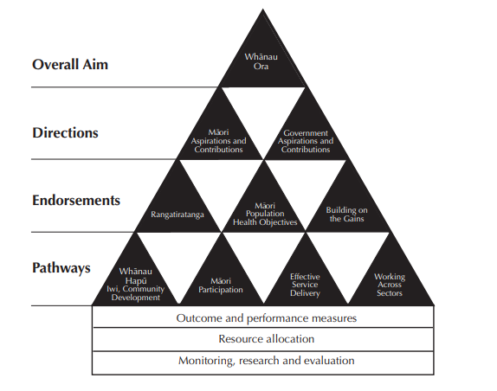
Figure 1: Framework of Maori health strategy
(Source: Cram et al. 2018)
As commented by Came-Friar et al. (2019), three principal threads are Rangatiratanga, reducing inequalities and creating on gains. There are also four different pathways through which these key threads can be achieved. These are development of Iwi, Hapu and Whanau community and Participation by Maori people. In addition to that, other pathways involve delivery of efficient services and working across varied health sectors. Overall aim is specific and stable which explains to achieve whanau ora (Came et al. 2016). He Korowai Oranga identifies that there should be relationship between disability and health organisation along with Maori.

Methods of aligning of Maori health strategy with New Zealand health strategy 2016
Key principles of health strategy of New Zealand 2016 are to improve health and well being of communities and people. As opined by Came & Tudor (2017), Whanau is considered as foundation or basis of specific Maori society. Whanau plays a crucial role as key source of identity, security, support and strength. This is helpful in providing wellbeing towards Maori collectively as well as individually. There was an older version of health strategy that was developed in the year 2000 and is updated in the year 2016. This strategy includes two different parts; future directions and roadmap actions (Came & Tudor 2016).
Future directions: This future direction portrays a higher level and innovative direction specialised for health system of New Zealand more than next 10 years from 2016 to 2026. Future direction under new guidelines of health strategy of New Zealand involves five significant and strategic themes. In reference to the opinion of Fernando & Moodley (2018), they are smart system, one team, high performance, valued performance, closer to home and people powered.
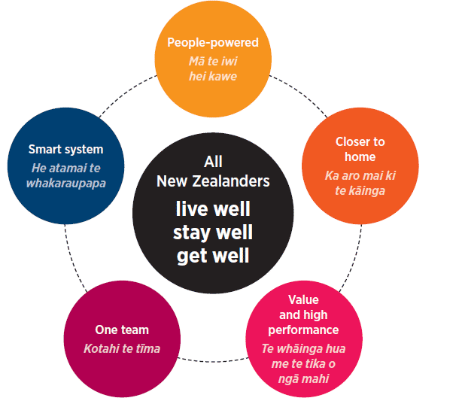
Figure 2: Future directions of Health strategy of New Zealand 2016
(Source: Fernando & Moodley 2018)
Roadmap action 2016: In order to keep strategy in place, this strategy is focused on recognising 27 areas over upcoming 5 years. As stated by Fernando & Moodley (2018), it has been committed by the strategy that it will remain under continuous updating. It will also act as practical guidance for NGOs, PHOs and DHBs and other important sectors. It is mediated in order to support respective planning and work prioritisation so that these strategies can be successfully delivered.
Role of the central government to determine legislation and policies supporting community health outcomes
Central government of New Zealand plays great role in providing policies and legislations in order to improve and protect Maori health.
- Tohunga Suppression Act 1907: This act is formulated by parliament of New Zealand. Key aim of this regulation is to replace tohunga with modern substitute medicines (Cram et al. 2018). Tohunga is considered as traditional healers among Maori communities.
- Health Act 1956: This act of health of New Zealand provides ministry of health, permit to improve, protect and promote public health.
- The Health Regulations 1996: This regulation confirms health information retention. As per their guidelines, health care agencies are required to pertain medical records of patients for a time period of about 10 years (Warbrick et al. 2016). The date will be counted from last time they received services from that health centre.

Health initiative that has been implemented in order to aid achievement of strategy
There are several organisations which have mediated several policies and guidelines in order to improve health factors of Maori community of New Zealand. Policy statement has been provided by college of medicine regarding public health of New Zealand. As per their policy statement, Maori people possess indigenous rights under treaty of Waitangi. Rights and claims of these indigenous Maori people have been preserved by United Nations as well. Fernando & Moodley (2018) state NZCPHM identifies significant health inequalities that persist between non-Maori and Maori New Zealanders. These inequalities are considered as pervasive and large over time and across lifespan. The vision of NZCPHM is to maintain just and fair society where Non-Maori and Maori people can get equitable health outcomes. NZCPHM identifies their responsibilities regarding Maori health (Ministry of Health, 2019). They also recognised possible obligations that they may get during providing equity towards non-Maori and Maori people.
Analysis of initiatives, guidelines and strategies that affects ethnic community
Success of this vision requires commitment to national level in order to achieve equity. According to opinions of NZCPHM, there are some health determinants that must be targeted. These are health care quality, timelines, access and housing education and income. (Breton et al. 2017) state United Nation also declared rights of preservation of indigenous Maori people of New Zealand. As per their declaration, rights and claims of Maori people are equal to general human health rights. These rights must consist right to self-determination, right to become liberal from any kind of discrimination. It also involves right to get respect as distinct individual or collectively (Ministry of Health, 2019). NZCPHM also mentioned that, both in present and past scenarios, Maori people became victim of discrimination and they were not capable to understand their rights. They also added that their rights for receiving respect are mandatory and these rights must be preserved.

Way to improvement of health outcomes by initiative supports
Health outcomes of Maori people can be upgraded by implementation of Maori disability and health workforce. In order to strengthen capacity of disability and health sectors, they require trained Maori clinicians, researchers’ voluntary workers, community workers, managers and several other health professionals. Better health outcomes can only be achieved when health is supported by additional factors such as healthy income, education, socio marital status and many others. Clinical training agencies and mental health funding have also extended financial aids to bring improvement in Maori people. Higher level of coordination and accelerations are required to ensure development of this workforce. Their cultural beliefs must be supported by modern and scientific approach. It should be concerned that, Maori people are not deprived of their rights. A supreme blend of traditional and scientific healing approach can be achieved through appropriate research.

Conclusion
The above study has provided an insight of health outcomes and opportunities of an Ethnic community of New Zealand namely Maori. This study also emphasises on guidelines, initiatives and strategies that impacts upon health and wellbeing strategy of ethnic communities.
From the above study it can be concluded that, Maori are discriminated community from other communities of New Zealand regarding health education, income and socioeconomic status. They must be replenished with absolute health benefits similar to other common citizens of New Zealand. Government of New Zealand also should recognise and value Whanau that can support disabled Maori people.

Reference list
Books:
Fernando, S., & Moodley, R. (2018). Global Psychologies: Mental Health and the Global South. Berlin, Germany: Springer. Retrieved from: https://books.google.co.in/books?hl=en&lr=&id=EgdiDwAAQBAJ&oi=fnd&pg=PR7&dq=Maori+Health+Strategy+book&ots=P-HddEevS9&sig=S4z8C8gFoRf1EAN-7NreDSV7dqs
Journals:
Came, H., & Tudor, K. (2016). Bicultural praxis: the relevance of Te Tiriti o Waitangi to health promotion internationally. International Journal of Health Promotion and Education, 54(4), 184-192.DOI: 10.1080/14635240.2016.1156009
Came, H., & Tudor, K. (2017). Unravelling the whāriki of Crown Māori health infrastructure. New Zealand Medical Journal, 130(1458), 42-47.Retrieved from: http://orapp.aut.ac.nz/bitstream/handle/10292/12295/Came-FINAL.pdf?sequence=2&isAllowed=y
Came, H., McCreanor, T., Doole, C., & Simpson, T. (2016). Realising the Rhetoric: Refreshing Public Health Providers' Efforts to Honour Te Tiriti O Waitangi. Retrieved from: https://openrepository.aut.ac.nz/bitstream/handle/10292/10313/Maori%20service%20delivery%202016-2-20.pdf?sequence=9
Came-Friar, H., McCreanor, T., Manson, L., & Nuku, K. (2019). Upholding Te Tiriti, ending institutional racism and Crown inaction on health equity. New Zealand Medical Journal, 132(1492), 62-66. DOI: 10.1016/j. socscimed.2014.01.055
Cram, F., Vette, M., Wilson, M., Vaithianathan, R., Maloney, T., & Baird, S. (2018). He awa whiria—braided rivers: Understanding the outcomes from Family Start for Māori. DOI: 10.18296/em.0033
Makowharemahihi, C., Wall, J., Keay, G., Britton, C., McGibbon, M., LeGeyt, P., ... & Signal, V. (2016). Quality improvement: indigenous influence in oral health policy, process, and practice. Journal of health care for the poor and underserved, 27(1), 54-60. DOI: 10.1353/hpu.2016.0035
Warbrick, I., Dickson, A., Prince, R., & Heke, I. (2016). The biopolitics of Māori biomass: towards a new epistemology for Māori health in Aotearoa/New Zealand. Critical Public Health, 26(4), 394-404. Retrieved from: https://openrepository.aut.ac.nz/bitstream/handle/10292/9447/Biopolitics%20Maori%20Biomass_finalrevision.pdf?sequence=5&isAllowed=y
Online articles:
Breton, M., Grey, C. S., Sheridan, N., Shaw, J., Parsons, J., Wankah, P., ... & Denis, J. L. (2017). Implementing community based primary healthcare for older adults with complex needs in Quebec, Ontario and New-Zealand: describing nine cases. International journal of integrated care, 17(2). (Online) Retrieved from: https://ijic.ubiquitypress.com/articles/10.5334/ijic.2506/ [Accessed on: 26 April 2019]
Website:
Ministry of Health (2019) He Korowai Oranga, Retrieved from: https://www.health.govt.nz/our-work/populations/maori-health/he-korowai-oranga [Accessed on: 26 April 2019]

