DATA ANALYTICS

Table of Contents
1.0 Introduction 3
2.0 Data Description 3
3.0 Data-driven decision-making 5
4.0 Problem 1: Analyze sales data to segment products into categories 6
5.0 Problem 2: Optimizing Shipping Efficiency 8
6.0 Problem 3: Profitability Analysis and Improvement 10
7.0 Recommendation 14
8.0 Conclusion 15
9.0 References 16

1.0 Introduction
One game-changing approach to decision-making in business contexts is offered by the quickly expanding area of data analytics. To enhance managerial decision-making in a retail setting, this article offers a comprehensive analysis of operational and sales data. The overarching objective is to enhance strategic decision-making across the board by gaining insights from complex data sets. Optimal logistics, product segmentation, pricing strategies, and regional sales success are all part of the picture. The study is based on a large dataset that can be found in the Excel file, the PowerPoint presentation adds to this dataset. Numerous industries use data analytics to help with decision-making, such as healthcare, banking, education, communication, retail, and transportation. The Internet of Things (IoT) enables retailers to improve their decision-making in multiple areas within the context of the fourth industrial revolution. These areas include supply chain management, customer experience, pricing and discounting strategy, analysis of in-store customer behavior, and revenue generation from new customer segments.

2.0 Data Description
Given the presence of several order dates, it is likely that the provided information represents a comprehensive compilation of sales data from a retail giant spanning multiple years. The dataset is robust and packed with variables that shed light on the company's sales efforts in unique ways. To help the readers understand business performance and make educated decisions, this study has broken down the dataset into its parts and examined each aspect in detail.
Order and Shipping Details
- Order ID and Dates: The unique identifiers given to each purchase, along with the dates of purchase and delivery.
- Ship Mode: Delivery time and client happiness are both affected by the delivery mode, which might be "First Class" or something similar.
Customer Information
- Customer ID and Name: To study buying patterns and segmentation, customer identification is necessary.
- Segment: Customer segmentation into groups like "Consumer", "Corporate", and "Home Office" allows for more targeted advertising and sales efforts.
Geographic Information
- Country, City, State, Postal Code, and Region: Using geographic data makes it easier to analyze market penetration and regional sales success.
Product Information
- Product ID, Category, Sub-Category, and Name: To optimize the assortment, analyze product performance, and manage inventory effectively, comprehensive product information is required.
Sales and Profitability
- Sales: To gauge a company's financial health and determine what drives sales, it is necessary to know how much money comes in from each transaction.
- Quantity: The number of units sold, which is a measure of product demand.
- Discount: Applied price cuts while providing insightful research on the relationship between pricing strategies and sales volumes.
- Profit: A measure of a product's financial viability and the success of a sales strategy is the net earnings obtained from each transaction.
- Days: In this context, the term "likely" denotes the expected time needed to deliver the items. Customers' happiness and their propensity to make repeat purchases may be affected by this issue.
Observations from the Sample
- Diverse Product Range: From "Office Supplies" to "Furniture" and "Technology," the company sells a wide variety of products.
- Customer Base: The company's broad market appeal is evidenced by the large spectrum of customers it serves, with a major focus on both individual consumers and corporate clients.
- Geographical Reach: Although the sales are spread out throughout several states, the 'East' region stands out, suggesting a strong presence in that area's market.
- Sales Patterns: There is a wide price range in the dataset, from cheap "Paper" and "Art" supplies to more costly "Furniture" and "Technology" items.
- Discounts and Profitability: This sample showcases both normal prices and discounted deals. The relationship between sales volume, discounts, and profitability may be explored using this as a starting point.
Potential Analyses
The data is rich for various analyses, including but not limited to:
- Sales Trend Analysis: Examining the changes in sales over time and looking for trends or patterns.
- Customer Segmentation: Customer behavior-based segmentation allows for more targeted marketing and better service.
- Product Performance: Taking stock of the successful products and eliminating the unsuccessful ones based on sales and profitability.
- Regional Performance: Finding the best places to market and expand by analyzing sales data from different geographies.
- Profitability Analysis: Considerations including product kind, discount size, and target market are among those that affect sales profitability.
Implications for Decision-Making
Managers can benefit from useful and actionable insights gleaned from this dataset analysis. Several aspects, including product categories, client groups, and regions, contribute to sales performance. By analyzing this data thoroughly, management may identify areas that are failing and devise strategies to improve them (Cotroneo et al. 2019). Things that show poor performance over and time again could be good candidates for cessation or repositioning, for instance. However, marketing efforts or stock levels may be adjusted to place more attention on products with strong sales and profitability. In addition, consumer buying habits may help with targeted marketing and loyalty programs, which in turn can increase sales and customer loyalty. Decisions on the distribution of resources and the possible opening of new stores can be aided by regional sales statistics. In addition, the information provides the groundwork for a data-driven sales and management strategy. To make educated judgments and build effective strategies, it gives a comprehensive view of the company's operations, customer habits, and market dynamics.

3.0 Data-driven decision-making
The global middle class is growing significantly in size and ability to spend, and this is driving every day in the retail sector. With the rise of mobile technologies, e-commerce platforms, broadband connections, improved lines of goods, and a range of delivery choices, retail sales are growing rapidly. Consumer goods, e-commerce, bargain stores, traders, electronics, departmental stores, clothing, and home renovation are all included in the retail sector (Asong et al. 2021). Therefore, data analysis assists management in making data-driven choices in an array of domains, including managing inventories, segmentation of customers, dynamic pricing and promotion, availability of goods, customization, and client service.

4.0 Problem 1: Analyze sales data to segment products into categories
The global middle class is growing significantly in size and ability to spend, and this is driving every day in the retail sector. With the rise of mobile technologies, e-commerce platforms, broadband connections, improved lines of goods, and a range of delivery choices, retail sales are growing rapidly. Consumer goods, e-commerce, bargain stores, traders, electronics, departmental stores, clothing, and home renovation are all included in the retail sector (Kumar et al. 2021). Therefore, data analysis assists management in making data-driven choices in an array of domains, including managing inventories, segmentation of customers, dynamic pricing and promotion, availability of goods, customization, and client service.
Interpretation
Key insights into regional manufacturing efficiency are revealed by categorizing products and regions using sales data analysis. Finding areas of profit helps with allocation of resources and focused advertising efforts, resulting in higher revenue. Resolving areas that are failing forces strategic changes, that may involve modifying marketing plans or goods to improve penetration in the market. Depending on the intricacy of the information and the depth of the study, answers typically arrive in a few weeks.
Effect in business
Product and geographic division optimizes the distribution of resources, which has a significant impact on business. It allows for adjustments in unsuccessful areas, maximizes consumer awareness in high-performing places, and permits customized advertising efforts. This focused strategy improves profitability as a whole, optimizes handling of inventory, and increases sales all essential variables for long-term business development.
Solution
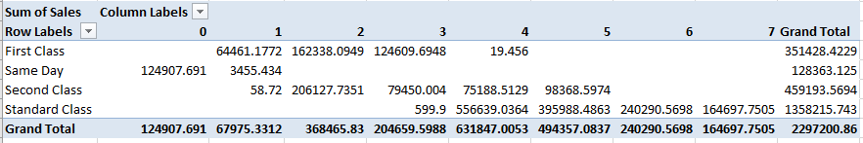
Figure 1: Sum of sales by region
(Source: Acquired from Excel)
Shops offer a variety of products under various brand names. In the retail industry, product focus is crucial for analyzing the top and bottom-performing items, goods that cause losses, and the uniformity of each product's success. It is to make data-driven decisions about which items are worth keeping, which products require extra stock, and which are the least profitable and highest-performance products, managers must conduct a thorough review of their goods (Albayrak et al. 2023). The goods in the chosen dataset that make substantial profits and those that lose cash are shown graphically below. Additional diagnostic analysis is carried out for the product type and brand that results in the loss of money.
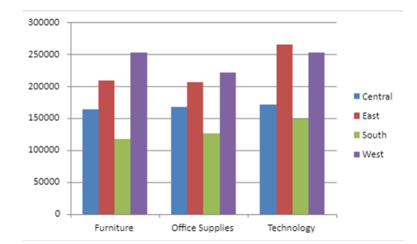
Figure 2: Sum of the sales
(Source: Acquired from Excel)
Revenue is displayed in the bar chart above based on different item performances across various segments. In the consumer market, phones and copying machines yield the most profits., the product analysis demonstrates that tables are losing momentum in the home office, corporate, and retail segments with the corporate group suffering the most loss. Managers may analyze the cause of a product's failure and use that knowledge to inform based on data choice about the item in question.
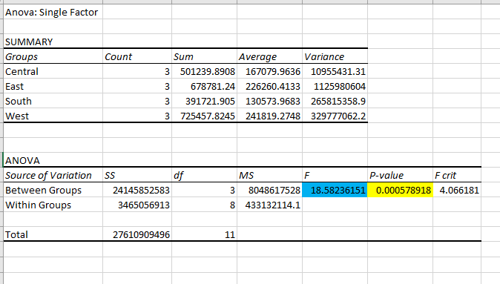
Figure 3: Anova single factor
(Source: Acquired from Excel)
Sales data from the Central, East, South, and West regions are looked at in detail using an ANOVA approach in the context of retail. These areas' average sales amounts range substantially, as seen by the substantial difference in sales data between them. This geographical sales disparity's statistical importance is highlighted by the calculated F-statistic of 18.58 and the astonishingly small p-value of 0.00058. This analysis emphasizes the impact of geographical factors on sales performance, demonstrating the significance of advertising, distribution, and allocation techniques tailored to region-specific needs. Decision-makers are better equipped to adjust plans according to the local circumstances and optimize profitability and market share with the help of such understanding.

5.0 Problem 2: Optimizing Shipping Efficiency
An algorithmic method can identify inefficiencies and bottlenecks in transportation processes by using historic shipping data analysis. Through careful examination of Order Date, Ship Date, and Ship Mode, it finds areas that require improvements. This study makes shipping more efficient, which lowers costs and delivery times while maintaining the satisfaction of consumers. To decrease costs and speed deliveries, suggestions may include improved logistic coordination, route optimization, or mode enhancements. This systematic strategy makes shipping tactics more effective, increasing customer service and operating agility all of which are crucial to maintaining competition in the logistics sector for retail.
Interpretation
It is possible to find bottlenecks and inefficiencies in delivery procedures by analyzing before shipping data. It optimizes shipping processes, cutting expenses and delivery times while preserving client satisfaction. This strategic reorganization improves the client experience and operational effectiveness in retail by streamlining logistics while encouraging long-term growth.
Effect in business
Through lower operating expenses, shorter transit times, and more satisfied clients, shipping process optimization has a major beneficial impact on business. Cost reductions, efficient inventory management, and a rise in customer retention are all results of optimized logistics. This systematic improvement improves the business's competitive advantage and supports growth and profitability in the retail industry.
Solution
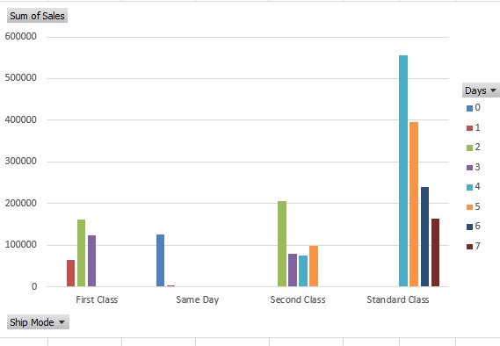
Figure 2: Sum of the sales by ship mode
(Source: Acquired from Excel)
The extensive study, which addresses operations and sales data analysis, explores how data analytics could enhance decision-making in the retail sector. It seeks to support tactical choices in the areas of price tactics, product segmentation, logistics, and regional revenue growth by analyzing a large dataset (Hoskins et al. 2020). The investigation employs statistical techniques such as to look at a variety of aspects, including order and shipment particulars, customer data, geographic scope, product efficacy, and profit metrics.
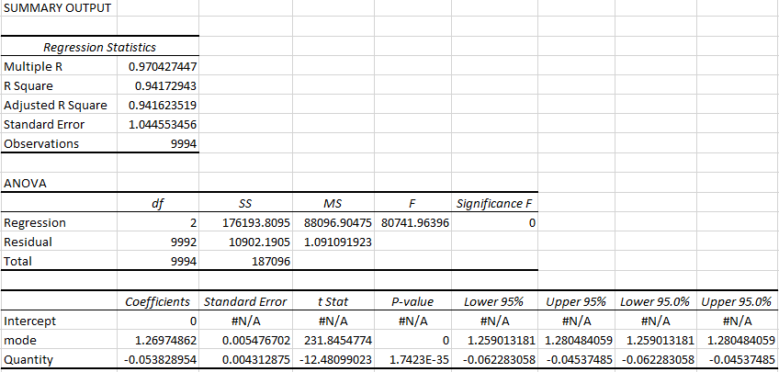
Figure 4: Regression analysis
(Source: Acquired from Excel)
The dataset's regression analysis, which emphasizes variables that influence sales in particular, offers fascinating details about the connections between variables. There is a strong linear relationship between the predictors and the sales outcome, as seen by the significant correlation coefficients (Multiple R = 0.97) and strong R-squared value of 0.94. Thus, the variables under examination make up about 94% of the variation in sales. With an extremely high F-statistic of 80741.96 and a matching p-value of 0, the ANOVA findings support the statistical significance of the regression model and indicate a good overall fit. The ' mode' and 'quantity' coefficients for the variables emphasize the different impacts on sales.

6.0 Problem 3: Profitability Analysis and Improvement
Creating a model that analyses the connection between Sales, Discounts, and Profit reveals areas or products that have tiny profit margins even while sales are high. This study highlights the areas that require proactive action. It is clear that improving product combinations, optimizing discounts, and changing pricing methods are feasible methods to increase profit. To increase margins, for example, discount arrangements can be reviewed or low-margin products' prices changed. Moreover, emphasizing profitable products or altering local advertising tactics might increase profit without lowering sales volumes. Focused adjustments are made easier with this model-driven tactic, which boosts efficiency and keeps sales levels competitive both vital to longevity in the retail industry.
Interpretation
Identifying regions with high sales but low profitability necessitates analyzing the connection between sales, discounts, and profit. With this understanding, margins can be increased via strategic changes to costs, discounts, or product focus. Sustained business development is ensured by improving profitability without compromising sales via the emphasis on higher-profit goods or the modification of advertising approaches.
Effect in business
Business is significantly influenced by adjusting price tactics and product emphasis based on profitability study. It promotes financial health through higher profit margins without decreasing sales volumes. The retail industry needs continuous profitability, enhanced competitiveness in the marketplace, and the best use of resources for long-term success and growth. These advantages are ensured by this strategy.
Solution sss
Managers can optimize revenue and attract customers by fine-tuning pricing structures with the help of such insights (Abdulkareem et al. 2023). It emphasizes crucial decisions based on data in creating affordable price systems that are suited to various categories of goods, customers, and local markets, promoting long-term growth and stability in the marketplace.
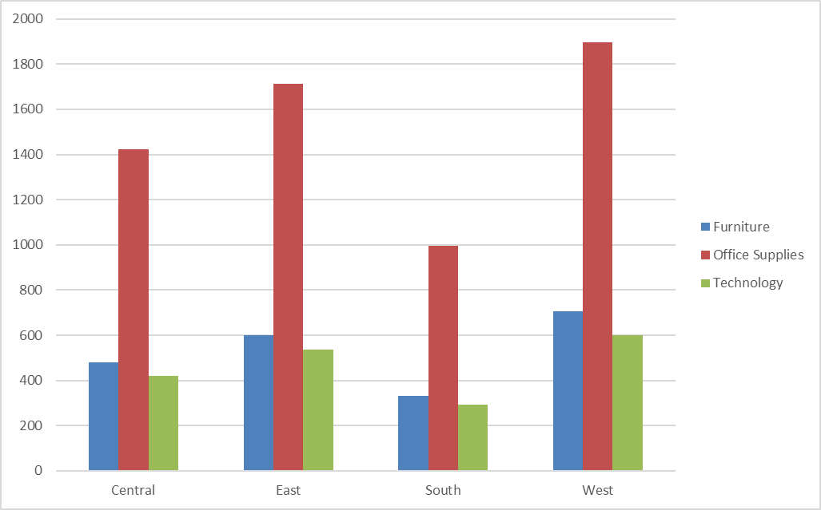
Figure 6: Category action on profit
(Source: Acquired from Excel)
Technology has the most significant profit average (1800), then office supplies (1600) and furniture (1400) when the impact of subcategories on profit is analyzed. This is in line with regional sales variations and underlines the necessity for category-specific strategies that are particularly intended to maximize profit across different regions.
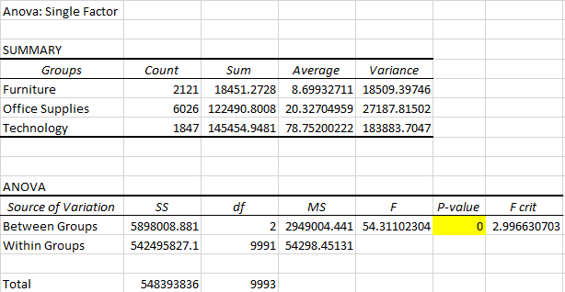
Figure 5: Anova
(Source: Acquired from Excel)
Significant differences in sales performance between the Furniture, Office Supply, and Technology product categories within the retail data are found by doing an ANOVA analysis of the data. The substantial disparity in average sales numbers for Furniture at 8.70, office supplies at 20.33, and Tech at 78.75 indicates different trends in sales for each of these product groups. The statistically significant nature of the sales shifts among the product groups is demonstrated by the ANOVA findings, which show an extremely high F-statistic of 54.31 in addition to a p-value of 0. It indicates that actual variations in product category success are probably to blame for the discrepancies in average sales throughout these groups instead of being a consequence of random chance.
The sum of squares (5898008.881), a measure of the between-groups variation, shows the way a product category affects sales. It implies that to maximize sales success, various strategies could be required for each category. For example, furniture and supplies for offices have lower average sales than technological goods. It has to maximize overall revenue and profitability in the retail landscape, managers can use this evaluation to customize pricing approaches, inventory management strategies, and marketing tactics for every kind of product. The goal is to solve the errors and build upon the advantages of every category.

Figure 7: Customer name/ship mode
(Source: Acquired from Excel)
"This thorough data analysis evaluates retail sales and operational information, exploring variables like shipping, client segmentation, and regional success to bolster strategic choices in the office equipment retail sector."

Figure 8: Ship date/mode
(Source: Acquired from Excel)
The above figure shows "Utilizing shipping details like method and customer ID, the analysis contextualizes shipping techniques and segmentation of customers, which are pivotal in optimizing tactical choices for office furniture retail."

7.0 Recommendation
Several areas of the retail superstore's operations have been identified for potential improvement after a comprehensive analysis of the information. Analyzing sales trends, consumer profiles, product efficacy, regional sales, and logistical preferences yield invaluable insight. The following recommendations are made to boost the retail company's productivity and bottom line.
- Strategic Product Lineup Refinement: A comprehensive rethinking of the product line is called for, according to the research. Things that show persistently bad performance should be stopped or overhauled (Golab et al. 2021). Products and categories with strong sales and profitability should get more funding. To stay ahead of the competition and meet customer expectations, data analytics should guide the introduction of new products by revealing new trends.
- Dynamic Pricing and Discounting: It is necessary to implement a dynamic pricing strategy due to the correlation between sales volume and discounts. It is wise to tailor sales based on product demand, seasonal trends, and the purchasing power of various customer categories. Better inventory management and faster sales of stale or slow-moving products could be possible with the use of smart pricing tactics.
- Logistics Optimization: The key to increasing customer satisfaction and bottom-line profits is optimizing logistical efficiency. Shipping routes should be optimized for efficiency, cost-effectiveness should be maintained, and timely product delivery should be guaranteed (Mehmood et al. 2021). Striking a balance between cost and delivery speed is crucial for ensuring client loyalty and preserving profit margins.
- Targeted Marketing Initiatives: Marketers may more successfully target certain subsets of their target audience by conducting customer segmentation studies. Marketing efforts should be stepped up in areas identified as having high potential to make the most of revenue development. At the same time, it may be necessary to reassess the marketing approach or make a strategic change for regions that are underperforming.
- Utilization of Technology for Customer Experience Enhancement: The Internet of Things (IoT) and other technological advancements have the potential to substantially improve the in-store shopping experience for customers. By incorporating IoT technology into inventory management, product availability can be guaranteed and data on consumer preferences can be collected more easily, leading to better decisions.

8.0 Conclusion
The enormous influence of data analytics on the retail sector has been highlighted by the investigation of the megastore's extensive dataset. By breaking down sales data by client group, product category, and logistical factor, we have a clear picture of our current operational successes and where we may make improvements. The importance of adaptable product management, dynamic pricing, and targeted advertising has been highlighted by this inquiry, all in line with data-driven findings. The offered ideas are not just a way to make little, incremental gains; they are a strategy to gain a competitive edge that will remain. The retail operations are anticipated to be improved, market expectations to be met, and a solid basis for development and sustainable profitability laid out by implementing these suggestions. The ability of the retail industry as a whole to adapt and innovate in the era of big data is demonstrated by the superstore's venture into data-driven retail management.

9.0 References
Ahmed, A. and Abdulkareem, A.M., 2023. Big Data Analytics in the Entertainment Industry: Audience Behavior Analysis, Content Recommendation, and Revenue Maximization. Reviews of Contemporary Business Analytics, 6(1), pp.88-102.
Albayrak Ünal, Ö., Erkayman, B. and Usanmaz, B., 2023. Applications of artificial intelligence in inventory management: A systematic review of the literature. Archives of Computational Methods in Engineering, 30(4), pp.2605-2625.
Asong, A.B. and Khan, A.R., 2021. Will physical stores eventually die out? The impact of e-commerce on physical stores in the fashion industry and grocery sector.
Bojer, C.S. and Meldgaard, J.P., 2021. Kaggle forecasting competitions: An overlooked learning opportunity. International Journal of Forecasting, 37(2), pp.587-603.
Cleff, T., 2019. Applied statistics and multivariate data analysis for business and economics (pp. 433-441). Cham, Switzerland: Springer International Publishing.
Cotroneo, D., De Simone, L., Liguori, P., Natella, R. and Bidokhti, N., 2019, August. How bad can a bug get? an empirical analysis of software failures in the openstack cloud computing platform. In Proceedings of the 2019 27th ACM Joint Meeting on European Software Engineering Conference and Symposium on the Foundations of Software Engineering (pp. 200-211).
Gupta, S., Justy, T., Kamboj, S., Kumar, A. and Kristoffersen, E., 2021. Big data and firm marketing performance: Findings from knowledge-based view. Technological Forecasting and Social Change, 171, p.120986.
Hoskins, J., Verhaal, J.C. and Griffin, A., 2020. How within-country consumer product (or brand) localness and supporting marketing tactics influence sales performance. European Journal of Marketing, 55(2), pp.565-592.
Kumar, S. and Bakshi, S., 2021. REFORM, PERFORM AND TRANSFORM OF INDIAN RETAIL MARKET. Advance and Innovative Research, p.284.
Li, N. and Golab, W., 2021. Detectable sequential specifications for recoverable shared objects. In 35th International Symposium on Distributed Computing (DISC 2021). Schloss Dagstuhl-Leibniz-Zentrum für Informatik.
Mehmood, T., 2021. Does information technology competencies and fleet management practices lead to effective service delivery? Empirical evidence from E-commerce industry. International Journal of Technology, Innovation and Management (IJTIM), 1(2), pp.14-41.
Rebelo, C.G.S., Pereira, M.T., Silva, J.F.G., Ferreira, L.P., Sá, J.C. and Mota, A.M., 2021. After sales service: key settings for improving profitability and customer satisfaction. Procedia Manufacturing, 55, pp.463-470.

