IMPACT OF NEW INSURANCE LIABILITY VALUATION STANDARDS ON STAR LIFE

Executive Summary
The purpose of this report is to evaluate the effects of the new insurance liability valuation standards in Star Life. Specific changes that the standards bring include deterministic cash flows, profit weighting, and Deferred Acquisition Costs (DAC) handling. The deterministic cash flow method improves the accuracy in liability valuation since there is better identification of the flow of cash and obligations in the future. However, immediate recognition of losses and smoothing of lifetime profits may have implications on reported profitability and regulatory capital in the short run. In general, the structure of the DAC asset, which captures 50 percent of the first commission costs, allows for the systematic depreciation of acquisition costs and can be a valuable tool when assessing financial health, provided that it is managed correctly. The report also assesses the extent of stakeholder influence while pointing out the significance of communicating with policyholders, shareholders and regulators to ensure that their expectations and concerns are met. Relative analysis with the current practices identify the gains and limitations of the new standards, hence the implications for change. Other approaches are stochastic modeling and market consistent valuation that have their advantages, but are still to be developed for further application. Recommendations include ones regarding proper compliance with key legislation as well as with PF 90, international standards. Based on the report, the new standards are challenging but advantageous for Star Life since they enhance the clarity and reliability of financial reports.

TABLE OF CONTENTS
1. Introduction 4
2. Analysis of New Standards 4
3. Stakeholder Impact Analysis 5
4. Comparison with Current Practice 7
5. Alternative Valuation Methods 7
6. Future Changes to Valuation Standards 8
7. Compliance with NZ Society of Actuaries Professional Standard 90 10
9. References 11
10. Appendices 14

1. Introduction
The insurance market leader Star Life has to navigate a challenging legal landscape determined by dynamic rules and norms. Since Star Life deals in life insurance, it is subject to regulatory standards that restrict unfair valuations of insurance liabilities. The current structure of liability regulation that is being used by the company relies on the outdated techniques of valuation of liabilities. Hence, the new insurance liability valuation standards are far from the historical practices. These new standards include techniques such as; deterministic cash flow forecasts, changes in profit improvement and loss recognition. Other significant amendments include the introduction of a DAC asset and the change of the period over which insurance liabilities are amortised. The main purpose of this report is to discuss the effects of these new standards on Star Life. Its purpose is to evaluate the impact of the proposed modifications of the business valuation methods on the company’s balance sheet, stakeholders and the main responsibilities for liabilities. Through analyzing those possible effects and comparing them to the existing state, this report aims at presenting solutions and guidelines on how Star Life can successfully transform with regard to regulatory requirements.

2. Analysis of New Standards
2.1 Deterministic Cash Flow Projection Method
One of the approaches that involve predicting anticipated cash flows in the future is the deterministic cash flow projection which assumes certain values in the future such as the claim rates and returns on investments. This method involves the computation of present value of expected cash flows using a predetermined discount rate as the projection is very certain (Goodman-Bacon, 2021). For Star Life, adopting this method has implications in the valuation of insurance liabilities since it paints a clearer picture on future cash requirements and financial obligations. It provides for the recognition of policy liabilities since it recognizes the expected cash flows from the policies. However, it may not fully take into account variability and uncertainties that may in turn influence the level of precision in the prediction of liabilities.
2.2 Profit Smoothing and Immediate Loss Recognition
It is the practice of distributing profits over the expected lifespan of an insurance policy instead of booking them all at once. This approach seeks to smooth operating income and give a better insight of operating performance. On the other hand, the direct write-off method involves writing off losses as soon as they are recognized, which affects the statement of financial position more significantly (West and Buckby, 2020). In the case of Star Life, profit smoothing is useful in improving financial stability and moderating fluctuation in the reported earnings so that it can work well in controlling the expected returns of investors. However, immediate loss recognition affects Star Life’s current financial statements and reserves and can harm its profitability in the short term.
2.3 Deferred Acquisition Cost (DAC) Asset
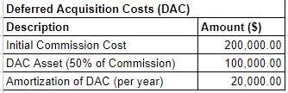
Figure 1: Deferred Acquisition Cost (DAC) Asset
(Source: Self-Created)
Deferred Acquisition Costs (DAC) refers to certain expenses made by an insurer in the process of selling insurance contracts, which are initially recognized and then spread over the useful life of the policies. This includes costs like commissions paid to agents. For Star Life, the DAC asset in the first year equals 50% of the commission cost, or $100,000. This amount is systematically written off over 5 years hence, $20,000 per year is written off as an amortization.
The consolidation of DAC assets ensures that Star Life applies the cost of acquiring these policies over the policy period, which enhances the short-term income (Popescu et al., 2023). However, this practice may hide the real-time effects of acquisition costs on the company’s bottom line and can definitely result in greater future liabilities since DAC assets are amortized.

3. Stakeholder Impact Analysis
3.1 Key Stakeholders of Star Life
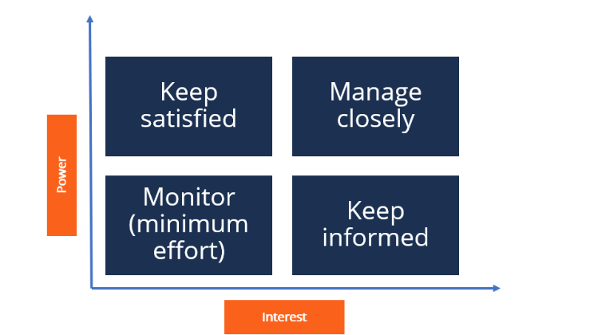
Figure 2: Stakeholder Impact Analysis
(Source: Wood et al., 2021)
The main stakeholders at Star Life are the policyholders, shareholders, regulators, and the management. Policyholders are important as they are the ones who are most affected by fluctuations in the insurance valuation policy, thereby affecting their policy benefits. This is because shareholders have an interest in the corporate performances and profitability of the business as any changes in these methods affect reported earnings and share prices. Supervisory bodies control the adherence of Star Life to industry and legal standards that affect business and financial performance and reporting (Corlette et al., 2020). These standards are implemented by management and the impact makes an appearance in strategic decisions and other modifications. Essential to note is the fact that every stakeholder group has its own interest and concern that must be accomplished in the best way possible to facilitate adoption of new standards in valuation that will be both responsive to the regulatory set rules and policies as well as the company’s financial objectives.
3.2 Impact on Stakeholders
New insurance valuation standards have the following implications to Star Life’s stakeholders. Policyholders can be impacted by these standards with regard to the valuation of benefits and stability of coverage that may result in changes in policy contract terms. It will be expected that with changes in these methods, stockholders’ elements will shift with effects on share prices and dividends (Boyle, 2022). While implementing the new standards, the regulators will need to check compliance and this might involve increased scrutiny and changes in the reporting frameworks. Leadership is tasked with the responsibility of integrating the new standards into the firm’s operations; this may entail modification of financial plans and controls for risks. All these stakeholder groups will have changes in their financial and operational relations with Star Life implying the need to manage changes in ways that avoid negative impacts and reconcile the parties with the new statutes.
3.3 Recommendations
To meet these stakeholders’ needs appropriately, Star Life should apply appropriate treatment on initial commission cost. The company should recognize 50% of the initial commission cost as a deferred acquisition cost (DAC) of $100,000. This approach enables Star Life to write off the DAC asset over five years by $20,000 every year consistent with standard industry practices and a logical and coherent method of expense recognition. The averages help shareholders in reducing the effect of fluctuating financial values, hence stability of financial statements. In the case of policyholders, it maintains the principle of policy values and benefits not to be subjected to the business risk of immediate recognition of costs (Logue and Grimes, 2022). Standardized amortization practices will be appreciated by the regulators as it increases compliance and transparency. In summary, this strategy is focused on the financial stability, regulatory and other requirements, as well as the expectations of the stakeholders that would enable a clear transition to the new standards of valuation.

4. Comparison with Current Practice
4.1 Advantages of New Standards
There are several benefits associated with the new insurance liability valuation standard as compared to the current practices. Firstly, the deterministic cash flow projection method is more organized in valuing liabilities as compared to the alternative method by offering improved accuracy and uniformity in reporting. New standards of revenue recognition and reporting that include profit smoothing provide a more stable representation of financial performance and eliminate the previous volatility (Liu and Liao, 2020). This practice enhances the credibility of financial statements and assists in effective risk management owing to the fact that losses are recorded without delay. Furthermore, the new standards regarding acquisition costs are more consistent with the industry’s practices, providing less confusion for expense amortization and improving the overall structure of financial reports. All these enhancements result in better presentation of financial information, enhanced compliance to rules and regulations and improved users’ information credibility.
4.2 Disadvantages of New Standards
However, the new standards have some limitations as well: There are however some negative implications of this shift to immediate loss recognition as some of the losses are recognized immediately this may have a negative impact on the reported profitability and the financial stability of the business. The deterministic cash flow projection method may provide a rigid framework that does not reflect all fluctuations and risks in the market, which can result in overestimation of some aspects, affecting financial planning and performance (Darch et al., 2021). The DAC assets appear to be most vulnerable to problems in regards to the matching concept due to which the management of the amortizations may be a difficult and time-consuming task. Furthermore, there is a need for additional administrative and operational changes when adopting these new standards, entailing implementation costs and necessitating staff development. All in all, although the new standards improve the aspects of transparency and accuracy, they bring some problems in the field of financial operations and business carrying out that Star Life is to face.

5. Alternative Valuation Methods
5.1 Overview of Alternative Methods
In addition to the deterministic cash flow projection method, there are several other valuation techniques that can be employed in estimating insurance obligations. For example, stochastic modeling uses such luck factors as random variables and probability simulations that are useful in addressing uncertainties or market changes. This approach gives a spectrum of possible values instead of providing ‘ point estimate’ which can be very beneficial in case of risk analysis and in utilizing variability of financials (Schwab, 2021). Market rationalisation involves adjusting the valuations with the current market conditions and prices and the valuations produced must be in line with the current market rates. This method is helpful in improving the quality of the valuations because it uses the current market information and the expectations.
5.2 Applicability to Star Life
To Star Life, the adoption of other valuation techniques could pose certain advantages. The use of stochastic models could improve the assessment and analysis of the existing risks since it shows the variety of possible outcomes and variability of the financial results (do Nascimento, 2022). This approach is specifically appropriate for valuing long term assets and cost of investment as it provides a much dynamic picture of the financial strength of the company. Market-Consistent Valuation, on the other hand, would put more practical and more appropriate valuation in line with the current market price of the company to reduce the valuation discrepancies. This could be especially helpful in determining the value of securities and ascertaining that assets and liabilities’ appraisal correspond to real-life situations (Palmborg et al., 2021). But the execution of these methods demands successful data systems, multifaceted modeling means, and more resources that might be unachievable for Star Life. All in all, although these other methods could improve the accuracy of this valuation and the management of risk, implementing them would require a consideration of cost-benefit analysis, and integration with company goals and objectives.

6. Future Changes to Valuation Standards
6.1 Alignment with International Standards
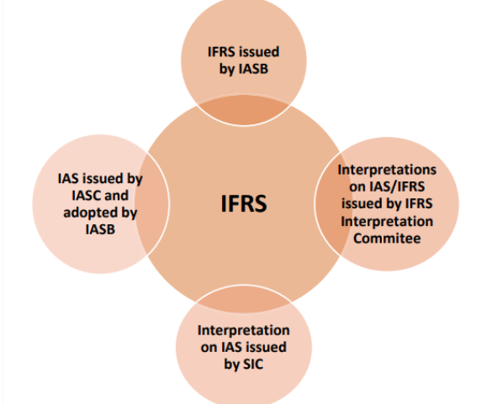
Figure 3: IFRS
(Source: Imhanzenobe, 2022)
The new insurance liability valuation rules implemented for Star Life are in line with other international standards such as IFRS 17 which seeks to offer more accurate measures regarding insurance contracts. Specifically, IFRS 17 focuses on the measurement of insurance liabilities using cash flow estimates of future cash collections adjusted for the time value of money and risks (Muchirahondo, 2020). The new standards, likewise, mandate probabilistic cash flow forecasting and discounting as per the IFRS 17 principles. However, there are some differences in the recognition and measurement of profit and use of deferred acquisition cost, where IFRS 17 provides more stringent tests for recognizing and measuring these costs. The new standards’ aggressive approach to profit smoothing and recognizing immediate losses is quite different from the objective IFRS 17 seeks to achieve in providing a more reflective and accurate portrayal of the economics of insurance contracts.
6.2 Potential Future Enhancements
However, to bring it in parity with the international standards, there are a few points that could be reinforced. First, the inclusion of stochastic modeling in the valuation process could offer a more comprehensive evaluation of the financial risks and uncertainties and correspond to the modern trends of international practices. Implementing this approach would supplement the absolute mathematically based outlooks by allowing the view of a variety of other possibilities (Dufrasne, 2020). Also, applying DAC treatment in line with the criteria expected from IFRS standard 17 could further improve the coherence in DAC and IFRS treatments, namely in regards to the recognition of the acquisition costs corresponding to the CSM approach. Additional future improvements could also consist in more advanced discount rate methodologies such as MCEV rate to enhance negative liability measurements. These changes would assist in positioning Star Life closer to the international standards and improving the soundness and credibility of its financial statements.

7. Compliance with NZ Society of Actuaries Professional Standard 90
7.1 Overview of Professional Standard 90
NZSA has developed Professional Standard 90 which outlines the standards for actuarial valuations and reporting. These include the need for actuaries to provide the best estimates of liabilities for insurance among other things. The standard demands that the methods and assumptions used would have to be reasonable in relation to the insurance contracts. It emphasises the importance of implementing new methods in the field of financial modelling and risk management and requires actuaries to justify reasons and purposes for the chosen assumptions and methods (Rajala, 2020). Moreover, it emphasizes the fact that the valuation practices should be periodically revised and updated in order to ensure that the used practices remain adequate and sufficient in different time intervals. Compliance with these standards makes the valuations credible and also guarantees that companies get similar valuation.
7.2 Star Life’s Compliance Strategy
For Star Life to achieve the Professional Standard 90, the company should establish a compliance framework. Firstly, the company should begin to establish a sound actuarial valuation model to ensure that all the methodologies and assumptions are to the standard. This involves ensuring the actuarial staff are provided with training and development to update their skills to meet the required standards as well as changes in the legal requirements. The documentation aspect policy requires that the documentation be professional, with justification for each and every assumption and/or methods of valuations used (Koskipalo, 2022). They should also carry internal audits now and then to assess their adherence to Professional Standard 90 and see where they have gone wrong. Hiring outside actuaries with regard to checking the work can offer further proof of compliance with the standard. Finally, it will be possible to encourage open discussion and embrace consistency with the professional standards as well as to adapt to any changes in the future.
8. Conclusion
The evaluation of the new insurance liability valuation standards shows that they have considerable consequences for Star Life. These results suggest that the adoption of deterministic cash flow forecasts improves the rigor and reliability of liabilities’ measurements to provide better information for financial reporting. The new standards’ concepts of profit smoothing and immediate losses recognition are both opportunities and threats; while converging financial statements with economic performance, they may first affect profitability and regulatory capital. The approach of handling Deferred Acquisition Costs (DAC) is more formal as to the expenses’ distribution but requires efficient control to prevent negative impact on the company’s results. The recommendations for Star Life are as follows: The first and most important recommendation is to establish a strong framework to integrate the above-discussed new standards into its system; second, all the valuation practices must be clear and compatible with the PS 90. The above changes require engaging key stakeholders in order to manage the expectations and explain the implications. The ICAEW opined that future developments to the valuation standards should aim at increasing convergence with international standards so as to promote cross-border comparability and consistency.

9. References
- Goodman-Bacon, A., 2021. The long-run effects of childhood insurance coverage: Medicaid implementation, adult health, and labor market outcomes. American Economic Review, 111(8), pp.2550-2593.
- Popescu, I.S., Gibon, T., Hitaj, C., Rubin, M. and Benetto, E., 2023. Are SRI funds financing carbon emissions? An input-output life cycle assessment of investment funds. Ecological Economics, 212, p.107918.
- Corlette, S., Blumberg, L.J. and Lucia, K., 2020. The ACA’s Effect On The Individual Insurance Market: An assessment of how individual health insurance markets evolved between 2014 and 2019, using metrics such as premium changes, insurer participation, and enrollment. Health Affairs, 39(3), pp.436-444.
- Logue, D. and Grimes, M., 2022. Living up to the hype: How new ventures manage the resource and liability of future-oriented visions within the nascent market of impact investing. Academy of Management Journal, 65(3), pp.1055-1082.
- Liu, C.C. and Liao, Y.P., 2020. Insurance acquisition costs: Capitalizing versus expensing. Journal of Accounting, Auditing & Finance, 35(3), pp.558-580.
- Darch, P.T., Sands, A.E., Borgman, C.L. and Golshan, M.S., 2021. Do the stars align?: Stakeholders and strategies in libraries' curation of an astronomy dataset. Journal of the Association for Information Science and Technology, 72(2), pp.239-252.
- Schwab, K., 2021. Stakeholder capitalism: A global economy that works for progress, people and planet. John Wiley & Sons.
- Palmborg, L., Lindholm, M. and Lindskog, F., 2021. Financial position and performance in IFRS 17. Scandinavian Actuarial Journal, 2021(3), pp.171-197.
- Dufrasne, L., 2020. " IFRS 17: a comparison with IFRS 4 and an analysis of the impact of its application. Louvain School of Management, Université Catholique de Louvain.
- Rajala, M., 2020. Expected effects of IFRS 17 on the transparency and comparability of insurance companies' financial statements (Master's thesis).
- Koskipalo, P., 2022. IFRS 17–Insurance contracts: Implementing the standard and its effect on measuring insurance contracts and financial reporting (Bachelor's thesis).
- Muchirahondo, G., 2020. Usefulness of IFRS 17 Insurance Contracts: Perspectives from South African Accounting Experts. University of Johannesburg (South Africa).
- do Nascimento, D.P., 2022. How Does the Introduction of IFRS 17 Impact the Measurement of Non-Life Insurance Contracts? a Case Study (Master's thesis, Universidade Catolica Portuguesa (Portugal)).
- Boyle, E.B., 2022. Justice for Our Genes: The Case for Genetic Non-discrimination Regulations in the New Zealand Life Insurance Industry. Journal of Law & Medicine, 29(3).
- West, A. and Buckby, S., 2020. Ethics education in the qualification of professional accountants: Insights from Australia and New Zealand. Journal of business ethics, 164(1), pp.61-80.
- Wood, D.J., Mitchell, R.K., Agle, B.R. and Bryan, L.M., 2021. Stakeholder identification and salience after 20 years: Progress, problems, and prospects. Business & Society, 60(1), pp.196-245.
- Imhanzenobe, J., 2022. Value relevance and changes in accounting standards: A review of the IFRS adoption literature. Cogent Business & Management, 9(1), p.2039057.

10. Appendices
Appendix 1: Projected Claims for Each Year
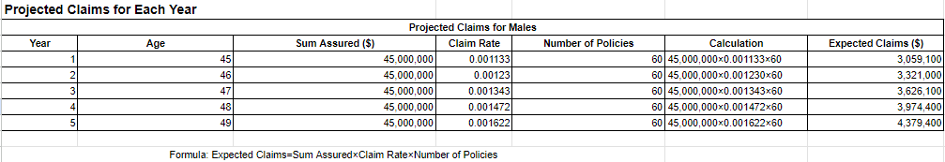
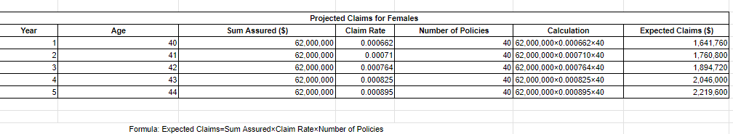
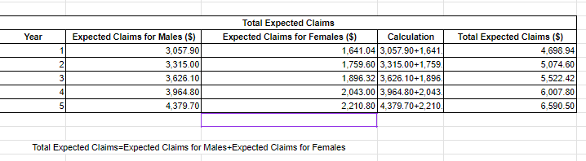
(Source: Self-Created)
Appendix 2: Discounted Cash Flows for Claims and Expenses
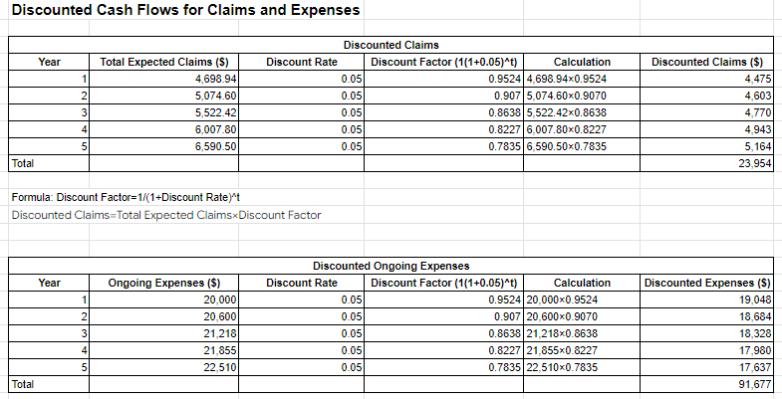
(Source: Self-Created)
Appendix 3: Total insurance liabilities and Net Present Value (NPV) of Liabilities
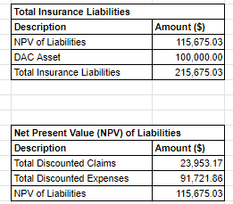
(Source: Self-Created)

