Indo-Canadian fast food restaurant
Business Proposal
Fast Food Restaurant Venture
Name of the Student
6/2/2017

Contents
Pricing 3
Promotional Strategy 5
Organisation 6
Operations 9
Financial 10
1. Application of Funds 10
2. Sources of Funds 11
3. Opening Balance Sheet 11
4. Projected Cash Flow 12
5. Projected Income 12
6. Projected Closing Balance 12
Appendices 13
Appendix-1 13
Appendix-2 14
Appendix-3 15
Appendix-4 16
Appendix-5 18

Pricing
Indo-Canadian is more customer-oriented so it believes in having a fair pricing strategy. Though it is not wholly dedicated to social service kind still it believes that pricing strategy should not be such that it will affect the business negatively. It will be introducing a blend of culture and taste of another country in Canada so it will not give a bad impression of that country based on which the business is expected to flourish in Barrie. Indian dishes are a favourite in Canada not only because of the taste but also because of the prices.
The prices of the food in the menu will be below market prices (though competitive). Since the restaurant will be launching its operations, the customers will also get a whole lot of offers and bonanzas. The initial week will give the customers more than 50% savings as compared to the other restaurants that are in full fledged operations. The early bird offers will also include surprise discounts for the customers. Apart from that the customers will get discounts amounting to anything from 15% to 25% on the total bill of purchase. A full plate Indian dish that will be enough for an adult will cost a mere $3.5 CAD. This is much cheaper as compared to the popular burrito which is something around $6 CAD. The pricing is excluding the discounts and the offers. A plate of “chola batura” or “mysore masala dosa” costs $3.5 CAD. One plate is enough for a grown up foodie adult. With one of these he can club either “dahi vada” or idli sambad” which is $2.75 CAD without clubbing. If the menu is clubbed then a person can get the dish for $2 CAD. So apart from the discounts and offers the normal cost of “mysore masala dosa” and “idli sambad” or “chola batura” and “dahi vada” would cost total of $5.5 CAD. This is more than enough for two persons having a full-fledged dinner in the Western culture. No other dish can be so cheap and also has the quality and taste.
However, the restaurant does not believe in resale strategies. So it might have a tough time to explain and convince the customers that Indian dishes are equally nutritious, health conscious, safe and tasty. But since customers are the business generators if ant customer is dead stuck on his requirement of having anything other than Indian menu for that reason there is also the option of popular continental and local foods. Though the foods will not be made in the Indo-Canadian kitchen still the menu will be supplied from the main dealers and / or distributors. However, the price will be matched and one can get the menu at the same price as one can expect to get anywhere else. Only there will be no discounts on the menu and the customers have to pay the full price. There will be a profit of additional 6% on the menu that will be resold after it is served to customer by Indo-Canadian.

Promotional Strategy
The company has its unique promotional strategy. It will be operating with the tag of India as its promotional base. To start with the company has set an initial annual sales turnover goal of $2 million. The net profit will be $1500 in the first month for each of the six partners involved in the business. The projected net profit for each of the partners is expected to increase by a minimum of 25% after six months in to the business.
The company will pitch for its sale of North Indian dishes. The Indian dishes on a whole will be more attractive because of the pricing strategy and the combination of the menus. But the varieties will be there more in the North Indian menus and also because of the presence of a sufficient number of North Indian people in the region of Barrie. So to ensure that the business takes off to a smooth start this is one of the promotional strategies that will be followed.
Along with this objective another objective set for the business to develop will be round the clock service and home delivery. The restaurant will be open 24 hours a day and 365 days a year. There will be no such thing as close or holiday for the restaurant. Though the restaurant will make enough arrangements to look that its workers are not over exhausted and sufficient rest is available to them. The company believes that to satisfy the customers the employees have to be kept happy then only they will serve the best to the customers. The restaurant can e accessed without any problem whatsoever because of the service. Apart from this there will be the facility of home delivery also. This will be doe at no extra cost. Often in the region there are home deliveries that are done with additional surcharges and also there has to be some minimum amount of purchases for the facility of hoe delivery to be taken. But Indo-Canadian has no such restrictions. There is no requirement of additional purchases from the restaurant or any minimum amount of purchases from the restaurant for the home delivery to be given. The customers can order any amount of food for being delivered to their home any time and it will be done free of any surcharges. This is not a promotional offer only. Rather it is another promotional strategy that the restaurant has made.
Another promotion offer as well as promotional strategy for Indo-Canadian is food pricing. Though it has been mentioned in the pricing section that the customers will benefit from the various pricing strategies of the restaurant still apart from that strategy the restaurant will also follow another strategy. It will provide free food as a gift for its 25th customer, 50th customer, 100th customers and so on. The clients will also be provided with surprise treats which will be absolutely free of cost. It will be the aim of the restaurant to give the customers maximum satisfaction and at the same time generate business. All this will be done keeping in mind the priority of the customers first and also maintaining the quality of the food. Apart from that health and safety issues will be of prime importance for the restaurant. It is a fact that adhering to the basics of ethics might have some problem in the business strategy in the early stages but in the future the company is sure to flourish.

Organisation
It will be of primary importance as to what the company formation base will be. It has to be noted that the initiative is from a bunch of entrepreneurs who are immigrants in Canada. Though there are two persons who are local in the region. As per rules and regulations of the state or the province no person from outside the country or those who are immigrants can start a business hassle free in the country. There lots of paper works and the pros and cons of the risk of starting a venture in Canada by an immigrant. So, for the best interest of the business venture that has been decided to carry out it has been decided that general partnership will be the ideal to start with.
For the general partnership to materialise it is important to take the nod of the provincial authority. Also it has to be informed to the authority of the residency status of all the partners involved in the business. The provincial authority should have to clear the issues related to residency in the primary stage so that the other formalities of the businesses can be started. Apart from the permission from the provincial authority the partners are required to take clearances from the local Barrie administration as well. It is to be remembered that in a general partnership all the partners are equally responsible for the firm that will be established. All the partners will have unlimited liability for the business venture that will be established. Even the partners will be responsible for each other’s actions related to the business establishment. So it is to be made clear that all the partners should be equally dedicated and responsible for the business that will be operating. The mental frequency and then business acumen should match amongst the partners. Any business decision should be taken in coordination and cooperation. Otherwise the venture will result in loss of finances and failure.
Apart from the above conditions there are few more conditions that have to be satisfied before the business is up and running.
- First it is to be confirmed that the name which has been decided for the business is available or not and if available whether it is permitted by the authority to use or not. This is only possible once the partners are clear of their views regarding the business to be formed.
- Then the next step is preparation and filing of the name in the Business Names Act. It should be noted that the name of the business cannot be more than 40 characters and also since the numbers of partners are less than 10 so the residential and legal details of all the partners have to provided so that Ontario registration number can be achieved.
- The partnership agreement has to be made properly in order of the business to function smoothly. The liability of the partners as per ss 10, 15, 18 and 13 of the Business Act should be consulted so that the partners are aware of their responsibilities.
- The partners should also be clear of the amount each one of them will invest and what will be the percentage of partnership of each of the partners. In a general partnership it is a practice of the trade that partnership percentage is normally proportional to the amount of money each partner invests in the business. Since capital is the main issue of a business so this one should be taken care of the most.
- Accounting principles, selection of auditors, fiscal year book keeping should also be taken care of. It is also of utmost importance since the business can come to a halt in spite of the revenue success. The company related business financials should be clear and up to date so that the business is not involved in any issues.
- The banking part of the business should also be taken care of. The bank facilities and relation with banks should be maintained and the company has to be in the good books as well since business loans are the main options for investment in the business.
- The company should have provisions for amendments and further modification as well as registration of the business.
- Determination of partnership property and insurance of the business venture should be clearly mentioned in the partnership agreement.
- There should be provisions for a new partner to be admitted in the business in future. Also there should be provisions for dissolution of the partnership or the business.
- There should also be provisions where details of the procedures should be mentioned in the case of death of one of the partners, bankruptcy of the business and retirement of one of the partners from the business.

Operations
It has already been mentioned that there are six partners in the business. Four of the partners are still to get permanent residency status in the province of Canada while two of them are locals.
The business functions will be divided accordingly so that it will not create any confusion in the operations. Also at the same time cooperation and coordination in the management is of utmost importance. There will be two main divisions; operations and marketing. Operations will be taken care of by one of the Indian partners since it also involves customer services and administration. What will be cooked and how that will be prepared is part of the restaurant management so an Indian experience is needed for it. The finances will be taken care of by a local. So will be the marketing. Actually marketing will involve another immigrant other than the local.
The tentative organisational chart is as given below.

In this chart the roles of the six partners have been defined clearly. The owner and managing director will be an Indian who will oversee the whole business functions. Since he has the main idea, so he knows in and out of the business. Under his supervision will be the chief operations officer and the chief marketing officer. The chief operations officer will essentially be an immigrant. The chief marketing officer will be a local since he has the geographical knowledge and the prevalent conditions of the market. Assisting him will be one of the immigrant partners. The administration manager will be an Indian whereas the finance controller will be a local as mentioned before. Any technicalities will be under direct supervision of the chief operating officer and will be assisted by the administration manager.
Apart from the six partners there will be additional staffs for the business operations to continue. So basically the 34 employed staffs on 24 hours basis are as follows;
- 01 x Main Supervising Chef (11:00 hrs to 23:00 hrs)
- 02 x Main Chefs (12 hrs basis each)
- 09 x Assistant Chefs (3 nos. in each shift of 8 hrs.)
- 12 x Waiters (4 nos. in each shift of 8 hrs.)
- 03 x Waitresses (1 no. in each shift of 8 hrs.)
- 02 x Sweepers / Cleaners (12 hours basis each)
- 02 x Security Guards (12 hours basis each)
- 02 x Cashiers (12 hours basis each)
- 01 x Delivery Boy for external official works (08:00 hrs to 20:00 hrs)

Financial
The financial section will show the brief of the following.

Application of Funds
Sr. No. | Item Description | Amount ($)
01 | Cost of facilities | 65,000
02 | Cost of equipments | 24,000
03 | Cost of furniture | 18,000
04 | Cost of vehicles | 35,000
05 | Cost of supplies | 17,000
06 | Cost of advertising | 15,000
07 | Cost for other start up | 18,000
08 | Total cost for start up | 1,92,000
09 | Requirement of Working Capital | 1,00,000
10 | Total Funds usage | 2,92,000

Sources of Funds
Sr. No. | Item Description | Amount ($)
01 | Partner Investment-1 | 45,000
02 | Partner Investment-2 | 35,000
03 | Partner Investment-3 | 35,000
04 | Partner Investment-4 | 25,000
05 | Partner Investment-5 | 25,000
06 | Partner Investment-6 | 25,000
07 | Cumulative Partner Savings | 37,000
08 | Total collateral | 2,27,000
09 | Amount to be financed by bank | 65,000
10 | Total Cash Source | 2,92,000

Opening Balance Sheet
Assets | Amount ($) | Liabilities | Amount ($)
Cash | 1,00,000 | Accounts payable | 0
Accounts receivable
Inventory |  | Total Liabilities | 0
Office space
Building |  | Owner’s Equity
Equipments & other assets | 77,000 | Paid in Capital | 1,77,000
 |  | Partner draw | 0
 |  | Retained Earnings | 0
 |  | Total Equity | 1,77,000
Total Assets | 1,77,000 | Total Equity & Liabilities | 1,77,000

Projected Cash Flow
The projected cash flow will be as per the plan devised by the management.

Projected Income
The projected income is estimated to be 35% over the investment amount post tax payment and liabilities payment.

Projected Closing Balance
In projected closing balance it is estimated that there will be net profit of 33% on yearly basis.

Appendices

Appendix-1
Monthly Sales Projections on a Daily Basis for a Year
Assumptions
 |  |  |  |  | # of Customers
Projected Customer Counts | Ave Check | Mon | Tues | Wed | Thurs | Friday | Sat | Sunday | Total | Total Sales
Lunch Food | 9.95 | 25 | 30 | 40 | 45 | 60 | 60 | 45 | 305 | 3,035
Lunch Bar | 2.75 | 25 | 30 | 40 | 45 | 60 | 60 | 45 | 305 | 839
Dinner Food | 13.95 | 25 | 30 | 40 | 45 | 60 | 60 | 45 | 305 | 4,255
Dinner Bar | 8.50 | 25 | 30 | 40 | 45 | 60 | 60 | 45 | 305 | 2,593
Night Services | 23.00 |  |  |  |  |  | 100 |  | 100 | 2,300
 | 0.00 |  |  |  |  |  |  |  | 0 | -
 |  |  |  |  |  |  |  |  | 610 | 13,021
Summary Totals
Weekly Food Sales | 9,590
Weekly Bar Sales | 3,431
Total Weekly Sales | 13,021
Monthly Food Sales | 40,755
Monthly Bar Sales | 14,583
Total Monthly Sales | 55,338
Food Portion of Sales | 74%
Bar Portion of Sales | 26%
Weekly Lunch Sales | 6,174
Weekly Dinner Sales | 6,847
 | 13,021
Lunch Sales to Total Sales | 47.4%
Dinner Sales to Total Sales | 52.6%
 | 2013 | 2014 | 2015
Annual Food Sales | 4,89,065 | 5,03,736 | 5,18,849
Annual Beverage Sales | 1,74,994 | 1,80,244 | 1,85,651
Total Annual Sales | 6,64,058 | 6,83,980 | 7,04,499

Appendix-2
Promotional Strategy Format
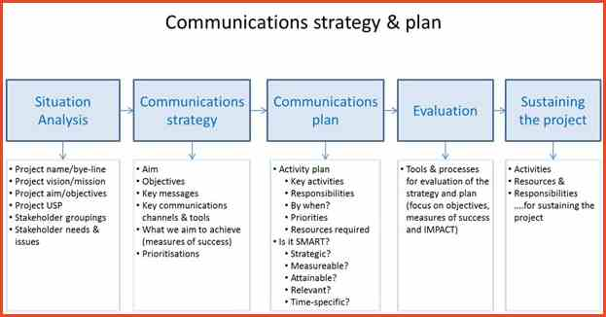

Appendix-3
Sample Partnership Agreement Form
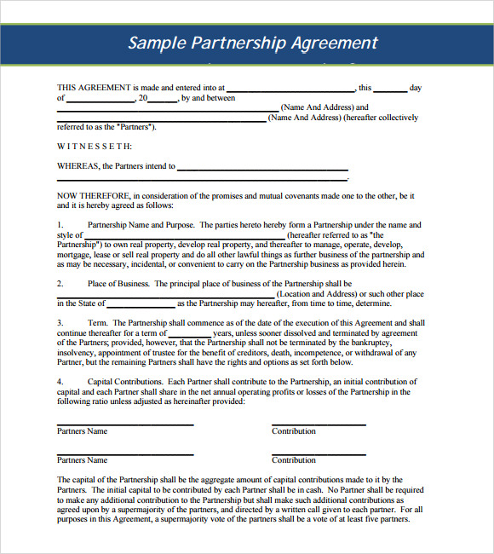

Appendix-4
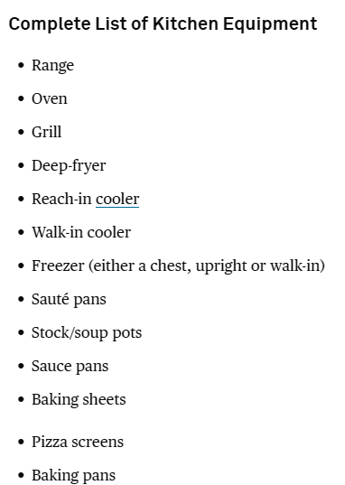
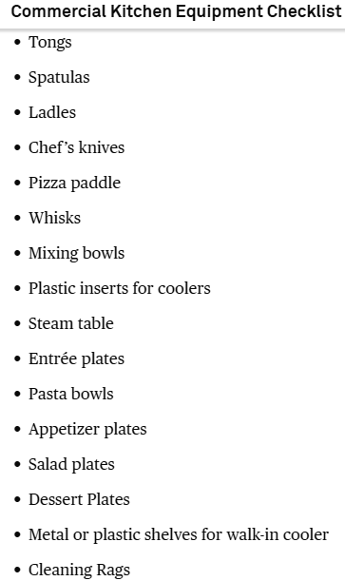

Appendix-5
Sample Blank Cash Flow Statement Form
Company Name:
Food Sales
Beverage Sales
Other Sales
GROSS SALES
Cost of Sales
Cost of Food
Cost of Beverage
Cost of Other
TOTAL COST OF SALES
GROSS PROFIT
General and Administrative
Employee Salaries (25%)
Management Salaries
Employer Taxes/Benefits (15% Wages)
Workers Compensation (6% Wages)
Marketing
Discounts/Promotions
Credit Card Charges
Insurance
Legal and Professional Fees
Linen
Misc. Other
Monthly Services
Office Supplies
Paper Supplies
Rent
Repair and Maintenance
Small Equipment
Telephone
Garbage
Utilities
Total Gen. and Admin. (Fixed)
NET PROFIT OR LOSS
SBA Loan
Cash Flow After Financing
Draw
Net Cash Flow
Revised 1/02

